Setup up Web application

Step 1: Install Required Packages

sudo apt update

sudo apt install -y apache2 curl unzip

Step 2: Verify Apache is Running

sudo systemctl start apache2

Refresh the host, you must able to see the apache

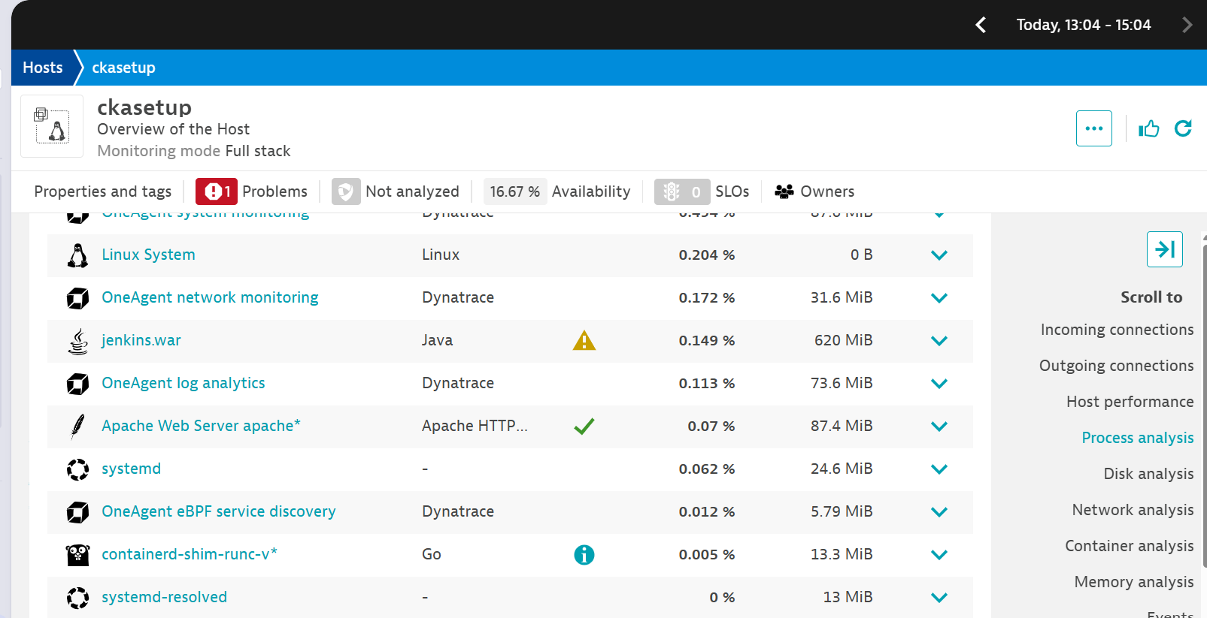

Create a index.html page

sudo bash -c 'cat <<EOF > /var/www/html/index.html

<!DOCTYPE html>

<html>

<head><title>My Dynatrace App</title></head>

<body>

<h1>Hello from Dynatrace RUM demo</h1>

</body>

</html>

EOF'

4) Check the web page

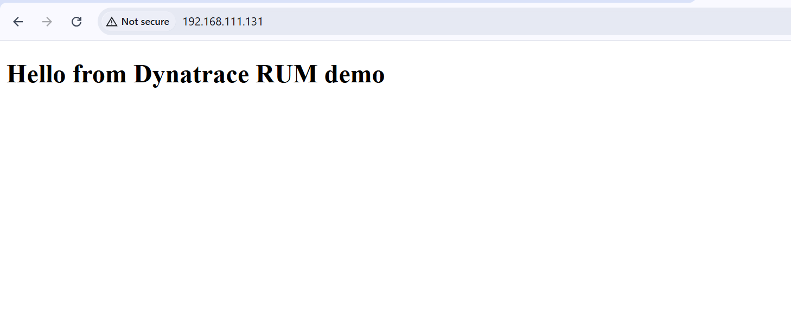

**Configure RUM for Your Application in Dynatrace**

Go to **Dynatrace UI → Applications → web**

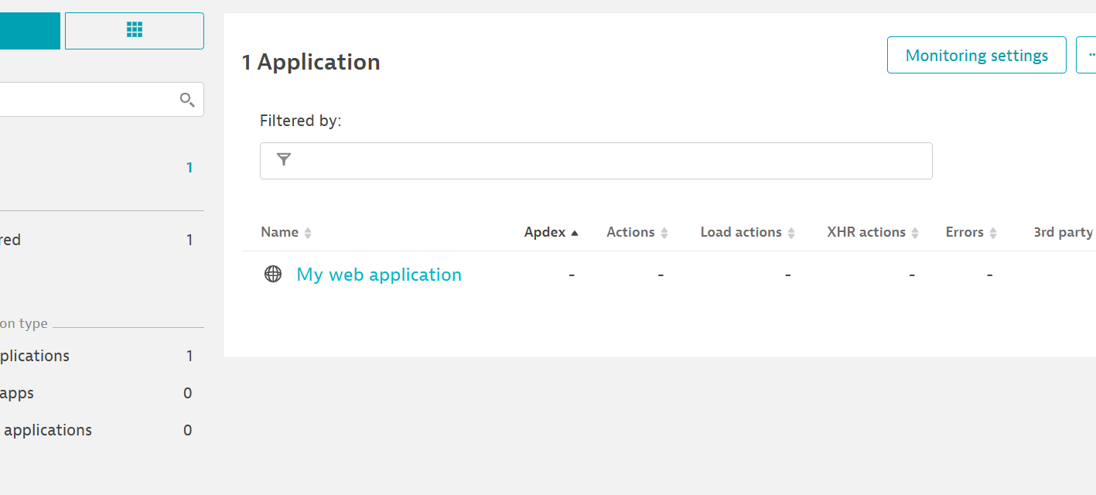

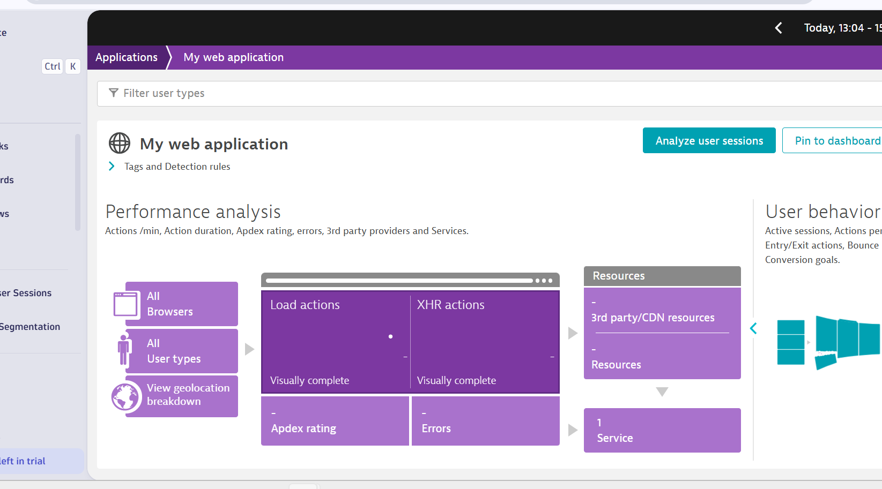

Try this lab on playgroud.

<https://github.com/dynatrace-perfclinics/dynatrace-getting-started#step-2-discover-dynatrace-playground-tenant>

click on app🡪search for web

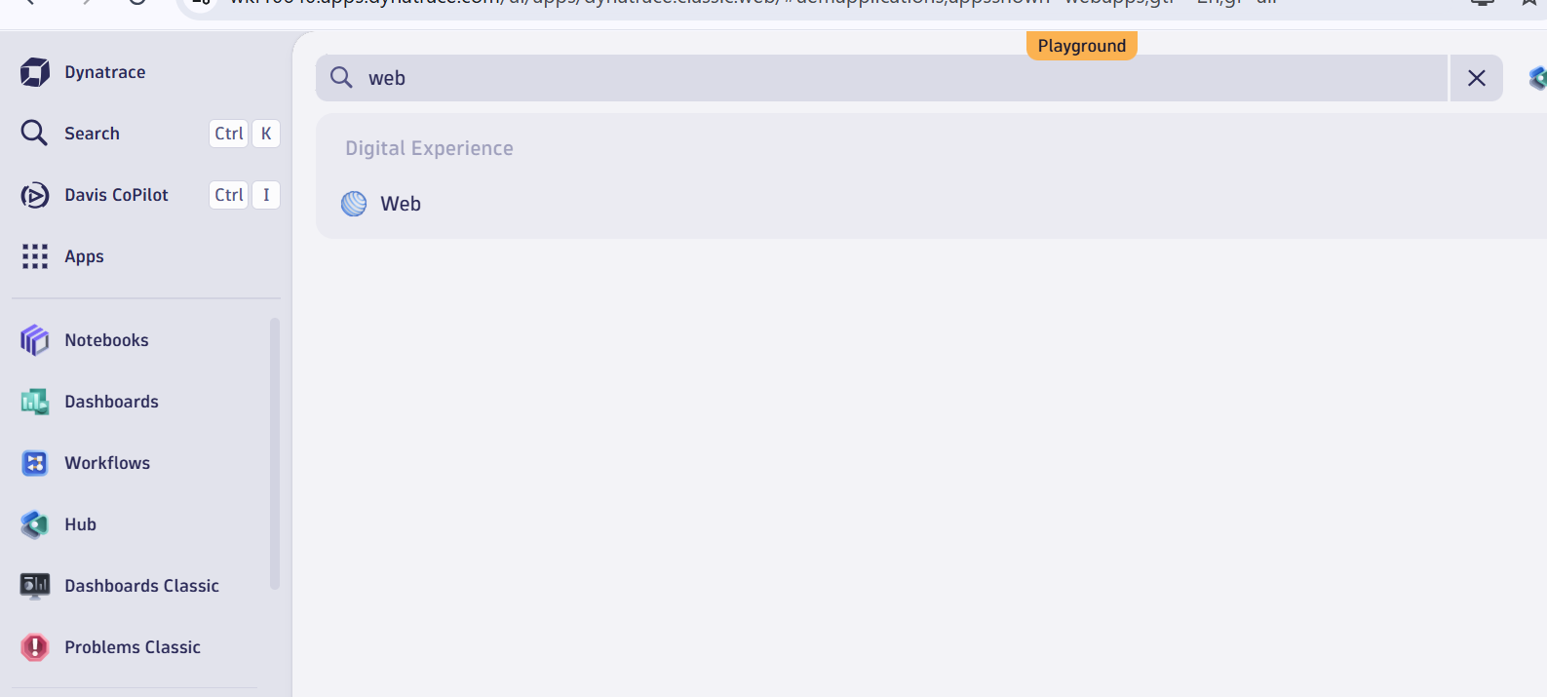

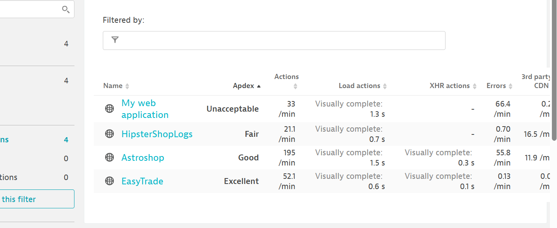

Check hipstershoplogs



Check dashboard

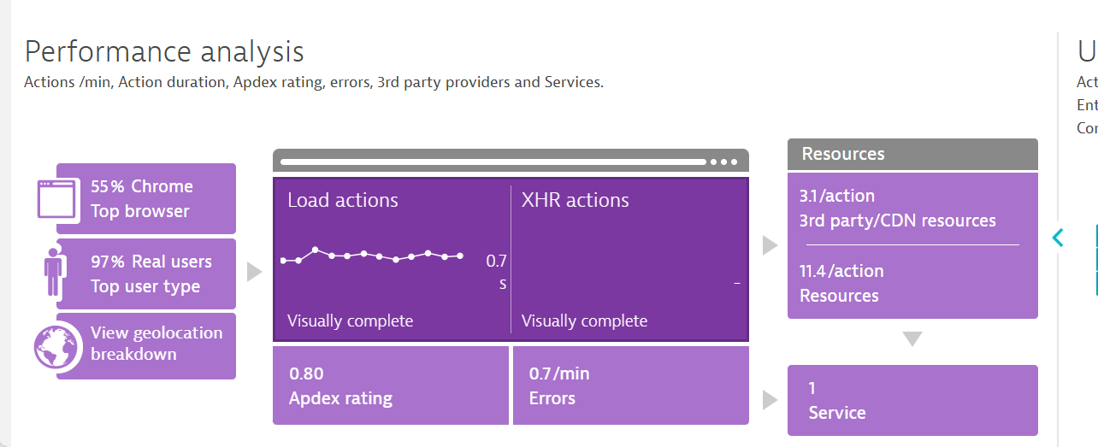

Response time

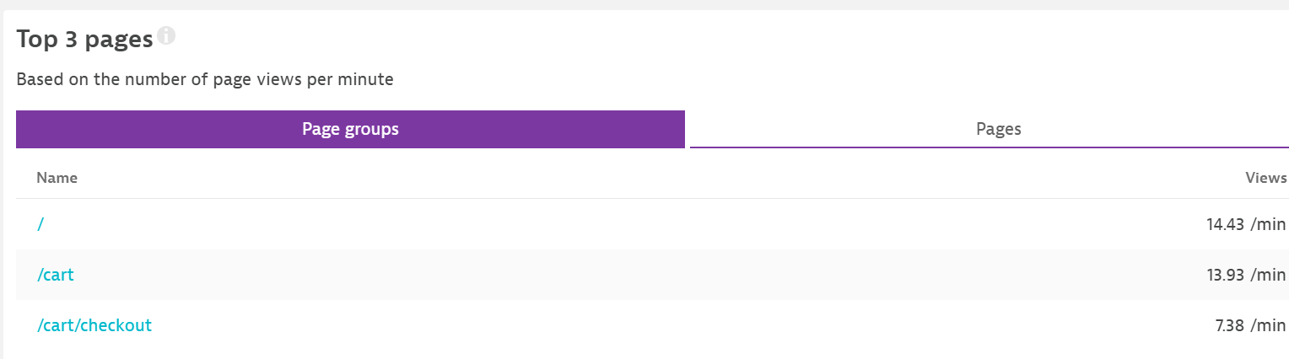

Top user action

